WEEK 5 EXTRA

1.

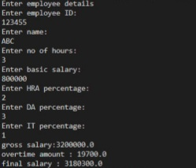

2.

